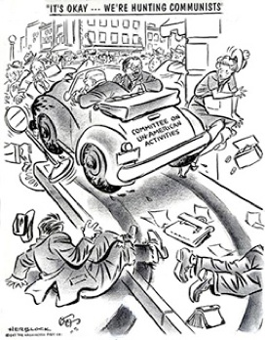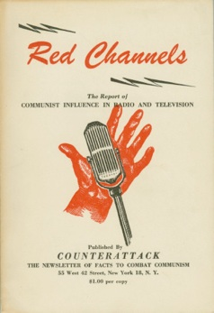

1. In the political cartoon on the left, what is the artist saying about the tactics of the HUAC and possibly Joseph McCarthy as well?

2. What image is used on the cover of the newsletter Red Channels to grab the attention of those concerned with communism in the US and in the media (radio & television)?

