Imperialism Primary / Secondary Sources Stations
Work with your partners to complete each task given. Envelopes will rotate appx. every 10-12 minutes so work deligently.
Envelope 1 – Hawaii and Alaska
After reading the material, devise a list advantages and disadvantages of American involvement in Hawaii. Then do the same with Alaska. Here are some questions to consider:
- How would the Natives of Hawaii felt about American involvement?
- What about the sugar planters?
- Did any of this arrangement seem sketchy or shady?
- Why was the Alaskan Purchase considered “Seward’s Folly”?
- Why did Russia wish to sell lands to America and not the British?
- Did any of this arrangement seem sketchy or shady?
- Which land acquisition was better for America at the time?

Hawaiian Advantages Hawaiian Disadvantages

Alaskan Advantages Alaskan Disadvantages

Envelope 2 – Mapping Imperialism
Use the red textbook, page 562, to locate and identify the 9 territorial possessions of the U.S. and then complete the chart that follows.
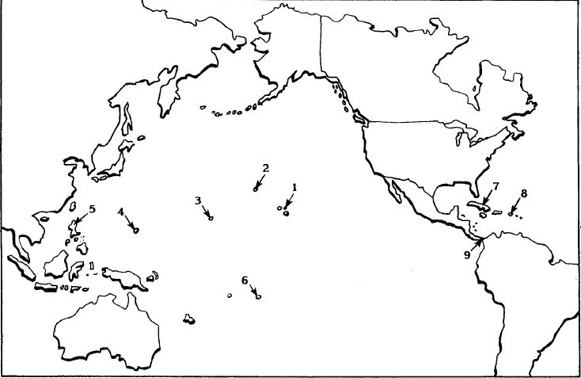
Territory | Date Acquired | Acquired From | How Acquired
1.Hawaii | 1887/1898/1900 | Queen Lilo, Hawaiian Mon | Direct – Dole & US Marines
2.
3.
4.
5.
6.
7.
8.
9.
Envelope 3 – Roosevelt Corollary and Monroe Doctrine
The word corollary, by definition, means this: statement easily proved from another: a proposition that follows, with little or no further reasoning, from the proof of another. This statement is a direct extension of the Monroe Doctrine. Read the original text and complete the organizer below.

Monroe Doctrine
Key Words:
_______________________________________________________________________________________________________________________________________________________________________________________________________________________________________________________________

Summary:
____________________________________________________________________________________________________________________________________________________________________________________________________________________________________________________________________________________________________________________________________________________
_____________________________________________________________________________________

In Your Own Words:
_________________________________________________________________________________________________________________________________________________________________________________________________________________________________________________________________________________________________________________________________________________________________________________________________________________________________________

Roosevelt Corollary
Key Words:
_______________________________________________________________________________________________________________________________________________________________________________________________________________________________________________________________

Summary:
____________________________________________________________________________________________________________________________________________________________________________________________________________________________________________________________________________________________________________________________________________________
_____________________________________________________________________________________

In Your Own Words:
_________________________________________________________________________________________________________________________________________________________________________________________________________________________________________________________________________________________________________________________________________________________________________________________________________________________________________

Envelope 4 – Yellow Journalism

Use your textbook to define yellow journalism and explain how it was used during events such as the Spanish-American War. Then use the box provided to create a sketch of your own yellow journalism headline of a major current event of today.

Yellow Journalism:

Explanation of Significance:

Envelope 5 – Imperialism Political Cartoons
In your groups, use the organizers to help analyze the imperialism cartoons.

Political Cartoon #1:

S –
E –
L –
A –
I –

Now put it all together:
- Describe the issue, event or idea being shown in the cartoon.

- What opinion or idea do you think the cartoonist is trying to convey with this cartoon?

- What would be the opposing viewpoint of the cartoonist’s opinion?

Political Cartoon #2:
S –
E –
L –
A –
I –

Now put it all together:
- Describe the issue, event or idea being shown in the cartoon.

- What opinion or idea do you think the cartoonist is trying to convey with this cartoon?

- What would be the opposing viewpoint of the cartoonist’s opinion

