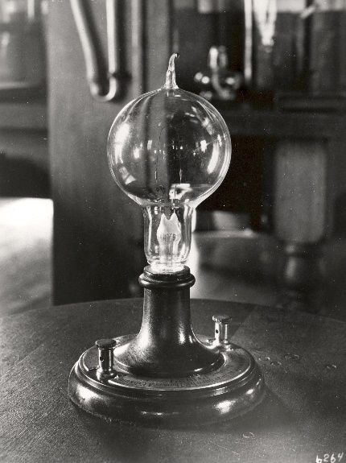

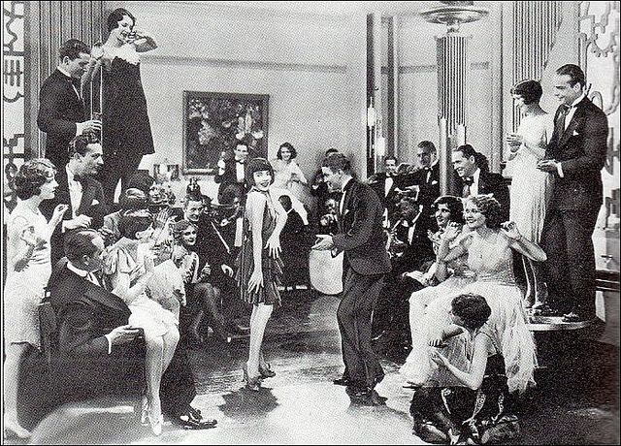
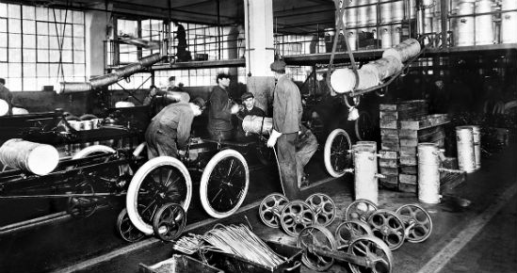

Look at the images above. The invention is on the left. The long-term effect is on the right. Answer each question below, then explain the cause-and-effect relationship between the two.
- Who is responsible for this invention / idea?
____________________________________________________________________________________________________________________________________________________________

- What immediate impact did it have on society? (Think about labor & efficiency progressives)
______________________________________________________________________________________________________________________________________________________________________________________________________________________________________________________________________________________________________________________________________________________________________________________________________

- Explain the cause-and-effect relationship between the images.
__________________________________________________________________________________________________________________________________________________________________________________________________________________________________________________________________________________________________________________________________________________________________________________________________________________________________________________________________________________________________________________________________________________________________

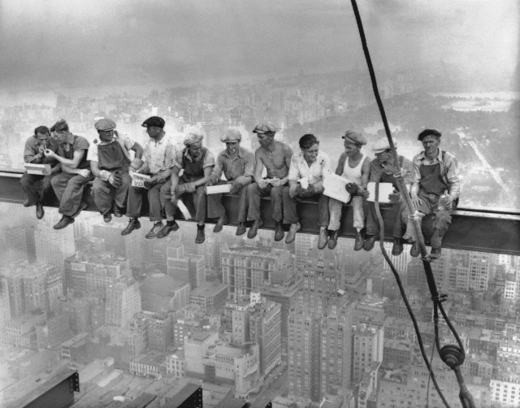
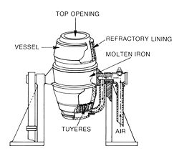
Look at the images above. The invention is on the left. The long-term effect is on the right. Answer each question below, then explain the cause-and-effect relationship between the two.
- Who is responsible for this invention / idea?
__________________________________________________________________________________________________________________________________________________________________________________________________________________________________________

- What immediate impact did it have on society? (think labor & efficiency progressives)
________________________________________________________________________________________________________________________________________________________________________________________________________________________________________________________________________________________________________________________

- Explain the cause-and-effect relationship between the images.
__________________________________________________________________________________________________________________________________________________________________________________________________________________________________________
________________________________________________________________________________________________________________________________________________________________________________________________________________________________________________________________________________________________________________________

- What problems arose in the US because of the government lacked control of businesses?
____________________________________________________________________________________________________________________________________________________________________________________________________________________________________________________________________________________________________________________________________________________________________________________________________________________________________________________________________________________

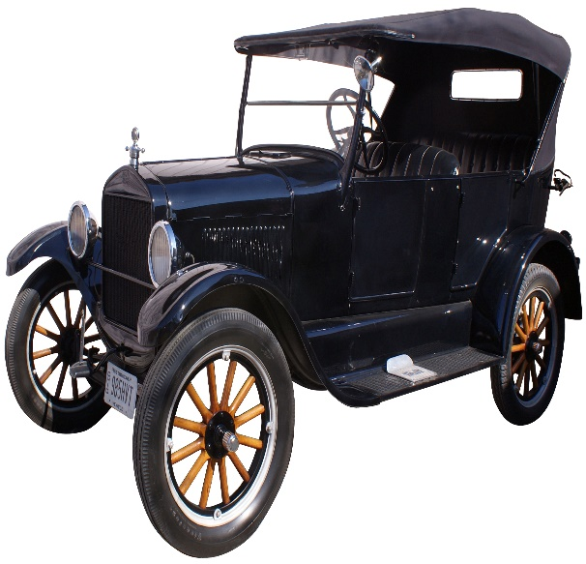
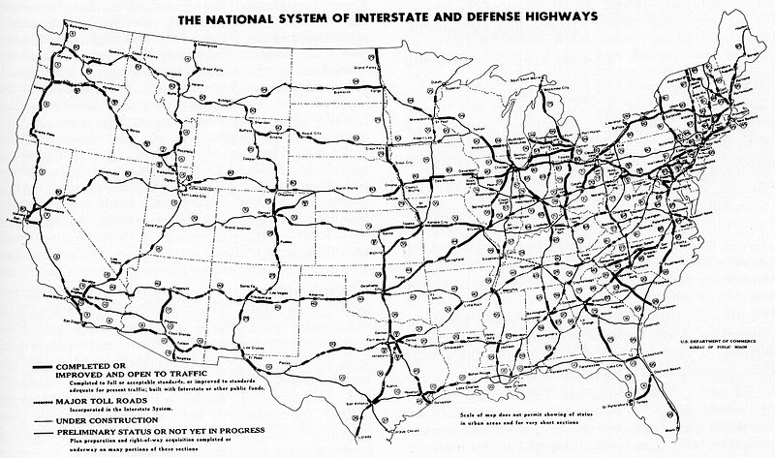
Look at the images above. The invention is on the left. The long-term effect is on the right. Answer each question below, then explain the cause-and-effect relationship between the two.
- Who is responsible for this invention / idea?
__________________________________________________________________________________________________________________________________________________________________________________________________________________________________________

- What immediate impact did it have on society?
______________________________________________________________________________________________________________________________________________________________________________________________________________________________________________________________________________________________________________________________________________________________________________________________________

- Explain the cause-and-effect relationship between the images.
________________________________________________________________________________________________________________________________________________________________________________________________________________________________________________________________________________________________________________________________________________________________________________________________________________________________________________________________________________________________________________________________________________________________________________________________________________________________________________

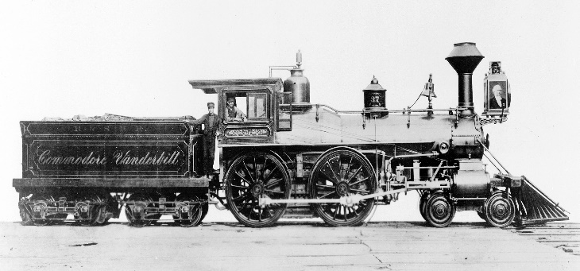
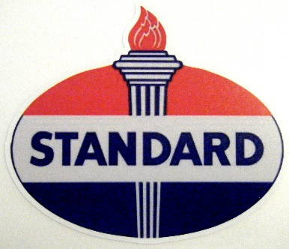

Look at the images above. The invention is on the left. The long-term effect is on the right. Answer each question below, then explain the cause-and-effect relationship between the two.
- Who is responsible for this invention / idea? Who were the leaders of the companies above?
____________________________________________________________________________________________________________________________________________________________________________________________________________________________________________________________________________________________________________________________________________________________________________________________________________________________________________________________________________________

- What immediate impact did their companies have on society?
______________________________________________________________________________________________________________________________________________________________________________________________________________________________________________________________________________________________________________________________________________________________________________________________________

- Explain the cause-and-effect relationship between the images.
__________________________________________________________________________________________________________________________________________________________________________________________________________________________________________________________________________________________________________________________________________________________________________________________________________________________________________________________________________________________________________________________________________________________________

