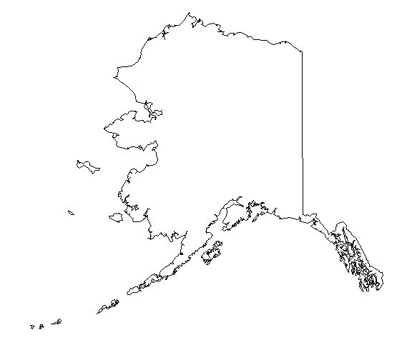

- What / Where is it?
____________________________________________________________________________________________________________________________________________________________

- From whom did the US get this territory and when?
____________________________________________________________________________________________________________________________________________________________

- How did the US obtain this territory? (Be specific and discuss methods & background.)
__________________________________________________________________________________________________________________________________________________________________________________________________________________________________________________________________________________________________________________________________________________________________________________________________________________________________________________________________________________________________________________________________________________________________

- Why did the US feel it needed this territory? (Be specific.)
________________________________________________________________________________________________________________________________________________________________________________________________________________________________________________________________________________________________________________________

- What / Where is it?
____________________________________________________________________________________________________________________________________________________________

- From whom did the US get this territory and when?
____________________________________________________________________________________________________________________________________________________________

- How did the US obtain this territory? (Be specific and discuss methods & background.)
__________________________________________________________________________________________________________________________________________________________________________________________________________________________________________________________________________________________________________________________________________________________________________________________________________________________________________________________________________________________________________________________________________________________________

- Why did the US feel it needed this territory? (Be specific.)
________________________________________________________________________________________________________________________________________________________________________________________________________________________________________________________________________________________________________________________

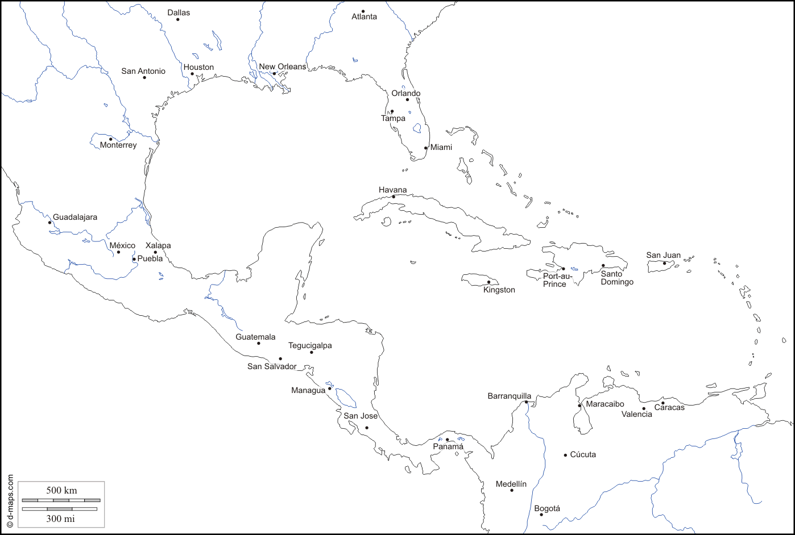
- What / Where is it?
____________________________________________________________________________________________________________________________________________________________

- From whom did the US get this territory and when?
____________________________________________________________________________________________________________________________________________________________

- How did the US obtain this territory? (Be specific and discuss methods & background.)
____________________________________________________________________________________________________________________________________________________________________________________________________________________________________________________________________________________________________________________________________________________________________________________________________________________________________________________________________________________

- Why did the US feel it needed this territory? (Be specific.)
________________________________________________________________________________________________________________________________________________________________________________________________________________________________________________________________________________________________________________________
What are the MAIN causes of WWI?
- M
- A
- I
- N
Draw a visual representation for the three reasons America entered WWI.

List three major effects the Great War had on American society in the decades following the war:
- Women –

- Production / Economy –

- Foreign Policy / Diplomacy –

