The New Deal Project
You (and a partner if you choose) will be assigned one of the 10-15 most important New Deal Programs enacted by President FDR. You will be working with this program for today and tomorrow. It is your job to become an expert in this platform. You must believe in it and sell it to your classmates. Your assignment will require you to complete this task, then present it to your classmate.
The programs to be assigned are:

• Emergency Banking Act
• Agricultural Adjustment Act (AAA)
• Civilian Conservation Corps (CCC)
• Federal Emergency Relief Act
• "Truth in Securities" Act (SEC)
• Tennessee Valley Authority (TVA)
• Home Owners' Loan Act (HOLC)
• National Industrial Recovery Act (NIRA)
• Glass-Steagall Banking Act (FDIC)
• Works Progress Administration (WPA)
• Wagner Act (NLRB)
• Social Security Act (SSA)
• Fair Labor Standards Act
• Security and Exchange Commission (SEC)
• Public Works Administration (PWA)

Create a New Deal Advertisement (15 points)
Your first task is to create a Billboard Ad, Newspaper Ad or something similar, selling your program to the American people and, more importantly, the Democratic-controlled Congress. Your ad must include the following:
- The full name of the program
- A catchy slogan clearly related to the purpose of the program (5 points – 0 points)
- An image and/or seal for the program clearly related to the purpose of the program (5 points – 0 points)
- A description of who the program helps and what the program does (5 points – 0 points)
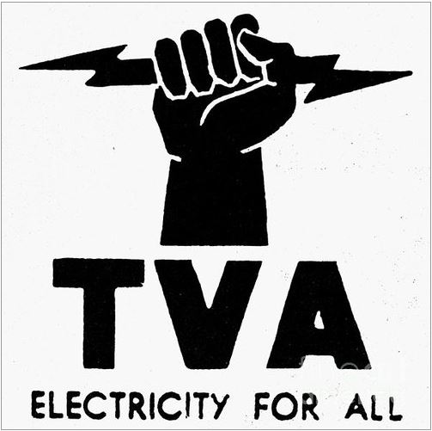
The Tennessee Valley Authority

