WWII in a Nutshell
Essential Questions:
- What was it like for typical Americans at home during WWII?
- How did it end and what are its lasting effects?
Learning Target – I can explain conditions at home for Americans during WWII and analyze the war’s impact on U.S. society.
Journal – When is it okay for the United States to get involved in foreign affairs? What justifies interference and/or involvement? Be specific in your response.
Vocabulary:
- War Production Board
- Battle of Midway
- Nuremburg Trials
Practice:
- Tuesday/Wednesday/Thursday Demonstration (10 minutes)
- Propaganda Poster Activity:
  - Station #1 Questions – Role of Women
    - What are women being asked to do by the government?
    - What overall goals will be achieved by these actions?
    - How are women portrayed in the posters (roles, images, emotions, feelings, etc.)?
    - Because the jobs taken on by women during the war focused on war production, what may result for women when the war has ended? Explain.
  - Station #3 – Role of Common Citizen
    - What are general citizens being asked to do by the government?
    - What overall goals will be achieved by these actions?
    - Define specific images used within the posters and explain their meanings
  - Station #2 – Role of Japanese
    - What are Americans being asked to do by the government?
    - What overall goal will be achieved by these actions?
    - How does the poster use stereotypes to send its message and what effect could that have on the Japanese-Americans in the US?
    - In the Dr. Seuss cartoon, what does the caption “Waiting for the signal from home” mean in the context of the war?
    - Explain the meaning of the sign stating “The Honorable 5th Column”
    - Is it surprising that the cartoon is by Dr. Seuss? Explain.
  - Station #4 – Role of Minorities
    - What are Americans being asked to do by the government?
    - What overall goal will be achieved by these actions?
    - How does the poster’s message of unity differ from the message society was sending to African-Americans at that time?
    - In the picture at the top left of the page, a worker tightens bolts in a mid-west airplane factory. What role has the African-American in the picture taken on during the war and why is that role important?
    - In the picture at the top right of the page, a bus is shown with a sign designating White Only seating. What does this image, taken at the same time as the image of the worker, say about the role of African-Americans in society during the war? Explain.
    - As an African-American, what would be your response to the conflicting messages being sent to you in terms of your role in society? Explain your feelings.
- WWII in a Nutshell PPT
  - Material to Cover:
    - Rationing
    - War Production Board
    - WAAC
    - Office of Price Administration
    - Manhattan Project/Oppenheimer
    - Battle of the Bulge
    - D-Day
    - Tuskegee Airmen
    - V-E Day
    - Nuremburg Trials
    - Hiroshima/Nagasaki
    - Yalta Conference
    - GI Bill of Rights
    - Japanese Internment
    - Korematsu vs. U.S.
Demonstration -
Homework – Study for test; complete study guide
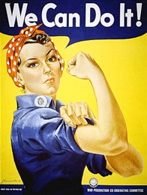
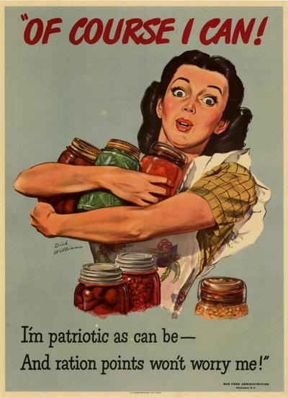
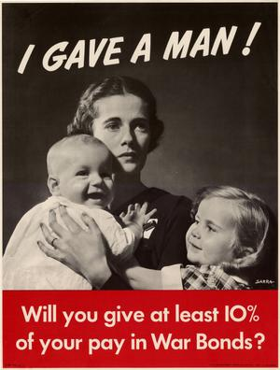

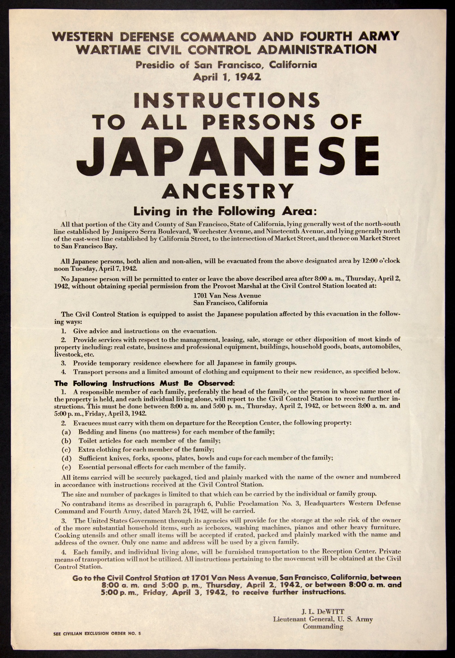
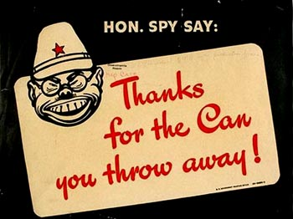
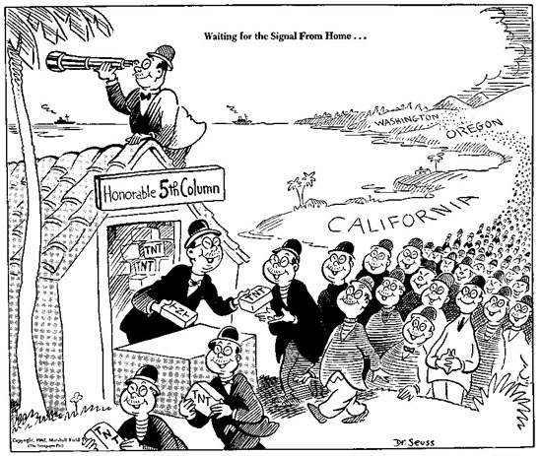

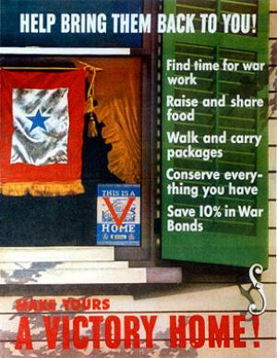

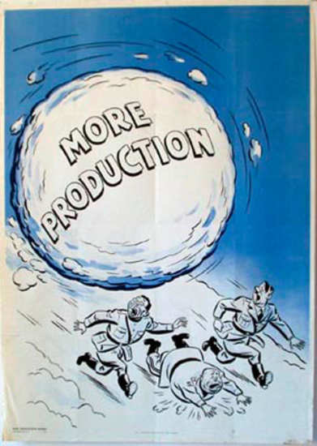
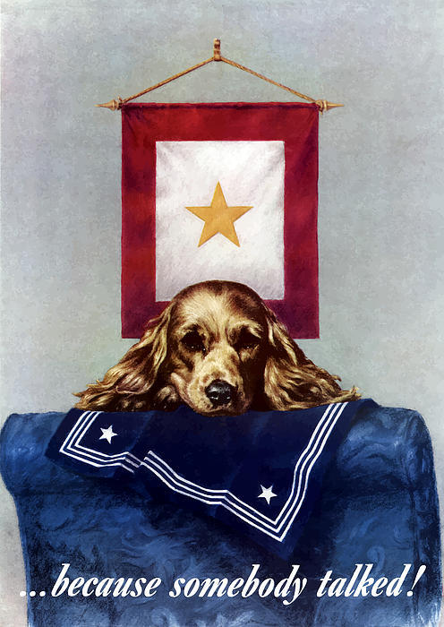
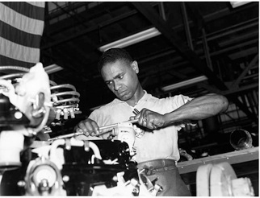

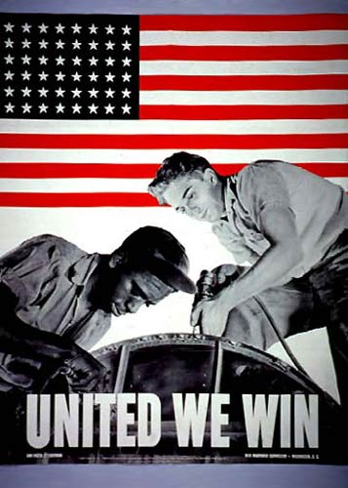

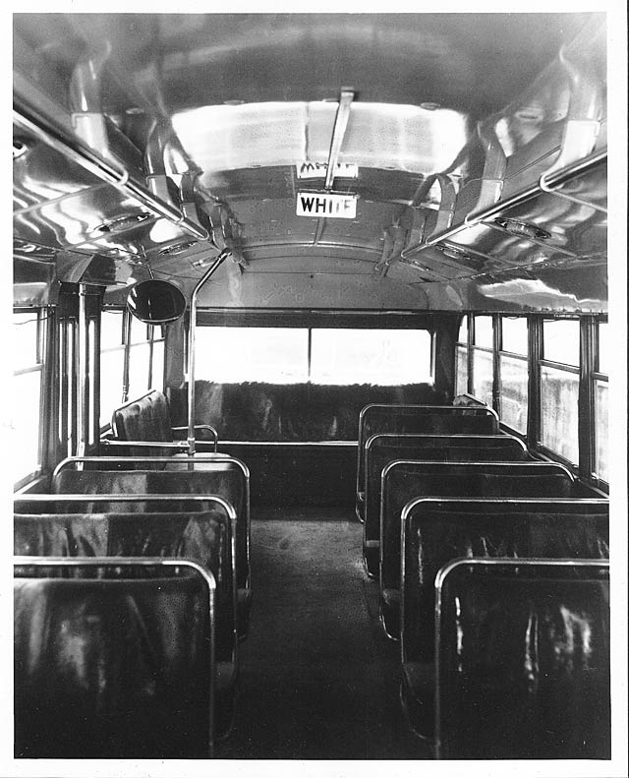
World War II Posters and Propaganda Gallery Walk Name:____________________

Station #1 Questions – Role of Women
- What are women being asked to do by the government?

- What overall goals will be achieved by these actions?

- How are women portrayed in the posters (roles, images, emotions, feelings, etc.)?

- Because the jobs taken on by women during the war focused on war production, what may result for women when the war has ended? Explain.

Station #3 – Role of Common Citizen
- What are general citizens being asked to do by the government?

- What overall goals will be achieved by these actions?

- Define specific images used within the posters and explain their meanings

Station #2 – Role of Japanese
- What are Americans being asked to do by the government?

- What overall goal will be achieved by these actions?

- How does the poster use stereotypes to send its message and what effect could that have on the Japanese-Americans in the US?

- In the Dr. Seuss cartoon, what does the caption “Waiting for the signal from home” mean in the context of the war?

- Explain the meaning of the sign stating “The Honorable 5th Column” the best you can (best guess.)

- Is it surprising that the cartoon is by Dr. Seuss? Explain.

Station #4 – Role of Minorities
- What are Americans being asked to do by the government?

- What overall goal will be achieved by these actions?

- How does the poster’s message of unity differ from the message society was sending to African-Americans at that time?

- In one image, a worker tightens bolts in a mid-west airplane factory. What role has the African-American in the picture taken on during the war and why is that role important?

- In a second image, a bus is shown with a sign designating White Only seating. What does this image, taken at the same time as the image of the worker, say about the role of African-Americans in society during the war? Explain.

- As an African-American, what would be your response to the conflicting messages being sent to you in terms of your role in society? Explain your feelings.

